* 1. 
  2. 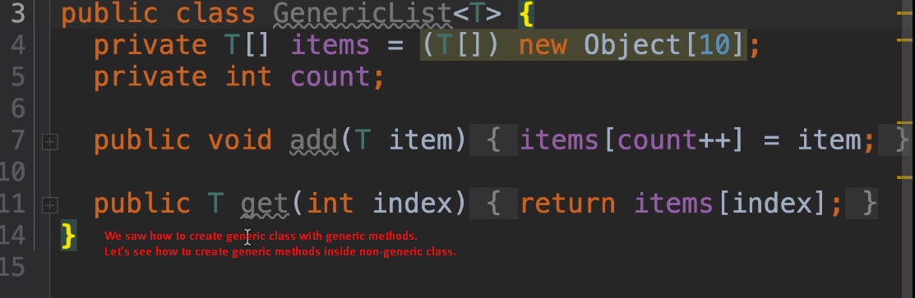
  3. 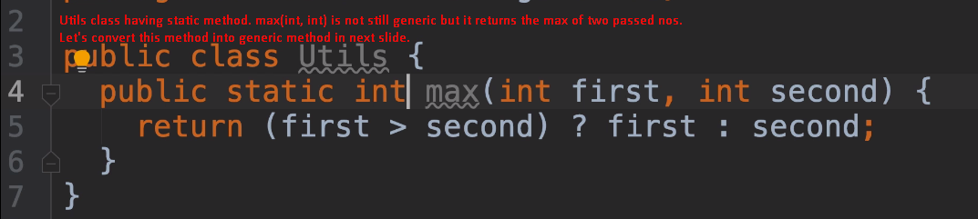
  4. Then how to compare two objects in the above generic method?
  5. As we’ve learnt about the Comparable interface. 0
  6. 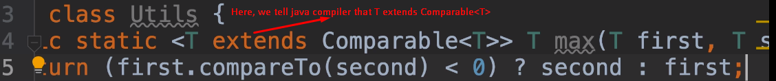
  7. 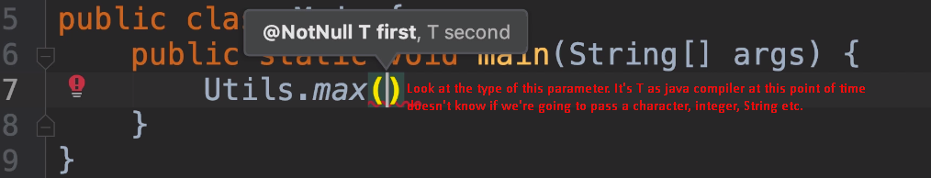
  8. 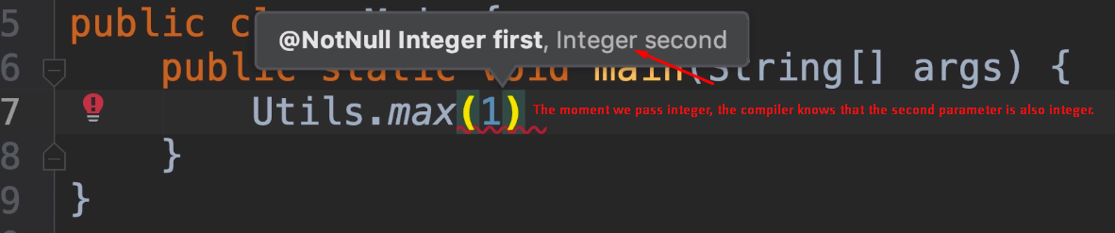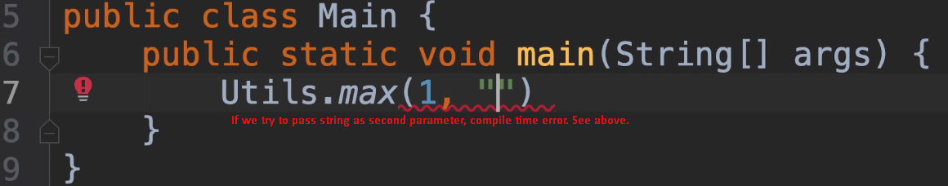
  9. 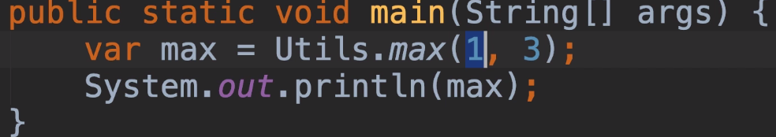
  10. 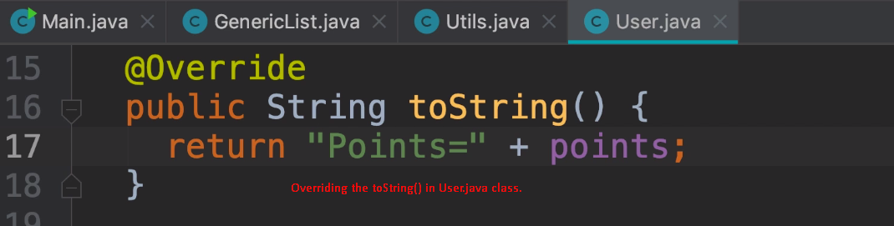
  11. 